AIAC ASSIGNMENT-11.5
NAME:T.Prashanthi
2303A52495
BATCH:50
Task Description #1 – Stack Implementation
Task: Use AI to generate a Stack class with push, pop, peek, and is_empty
methods.
Sample Input Code:
class Stack:
pass
Expected Output:
• A functional stack implementation with all required methods and
docstrings.
PROMPT:
# Implement a Stack class in Python
#Methods:
#push(item)
#pop()
#peek()
#is_empty()
#Add proper docstrings for each method
#Handle edge cases (empty stack)
#Include test cases with output

CODE:
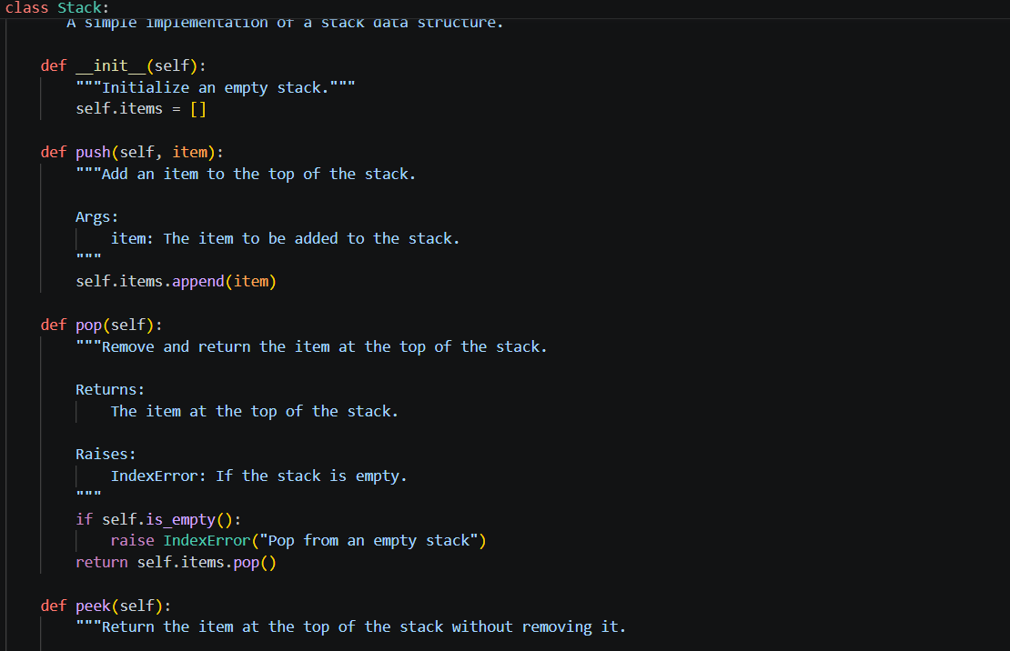
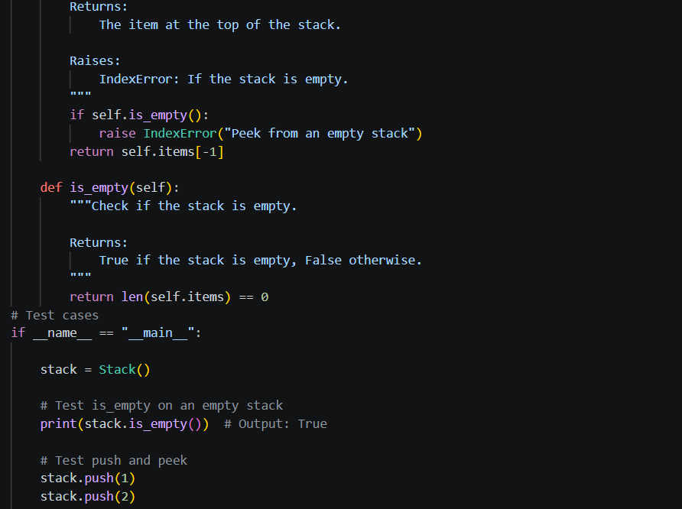
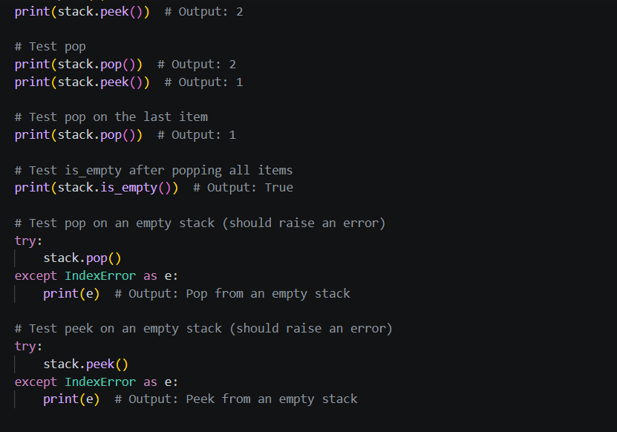
OUTPUT:
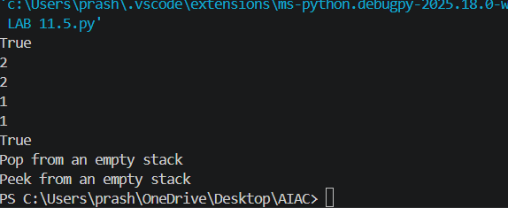
Task Description #2 – Queue Implementation
Task: Use AI to implement a Queue using Python lists.
Sample Input Code:
class Queue:
pass
Expected Output:
• FIFO-based queue class with enqueue, dequeue, peek, and size
methods.
PROMPT:
# Implement a Queue class using Python list
#Methods:
#enqueue(item)
#dequeue()
#peek()
#size()
#Follow FIFO (First In First Out)
#Handle empty queue cases
#Add docstrings
#Include test cases with output
CODE:
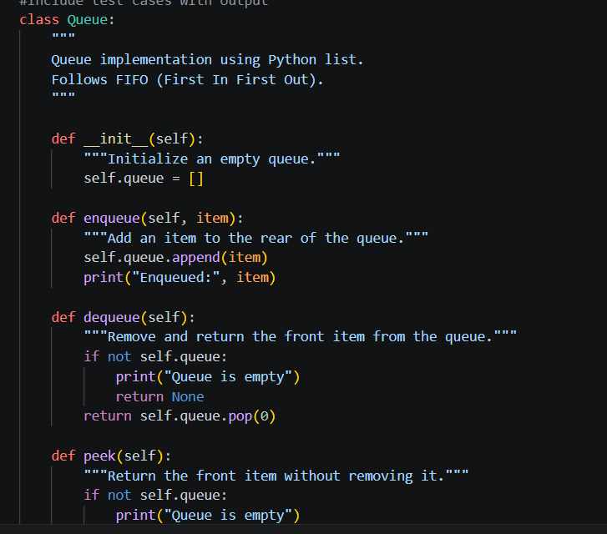
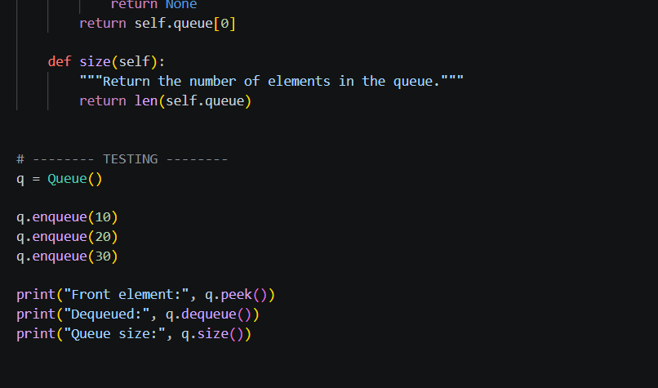
OUTPUT:
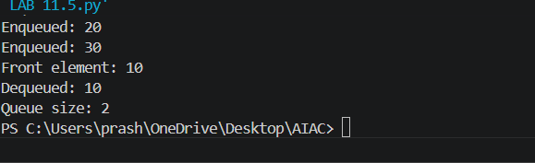
Task Description #3 – Linked List
Task: Use AI to generate a Singly Linked List with insert and display
methods.
Sample Input Code:
class Node:
pass
class LinkedList:
pass
Expected Output:
• A working linked list implementation with clear method
Documentation
PROMPT:
#Implement a Singly Linked List in Python
#Create Node class
#Create LinkedList class
#Methods:
#insert(data) → insert at end
#display() → print all elements
#Add proper docstrings
CODE:
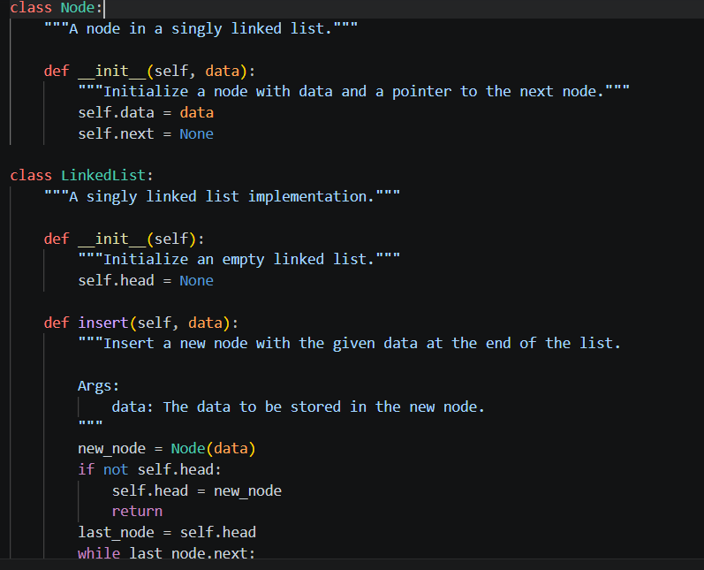
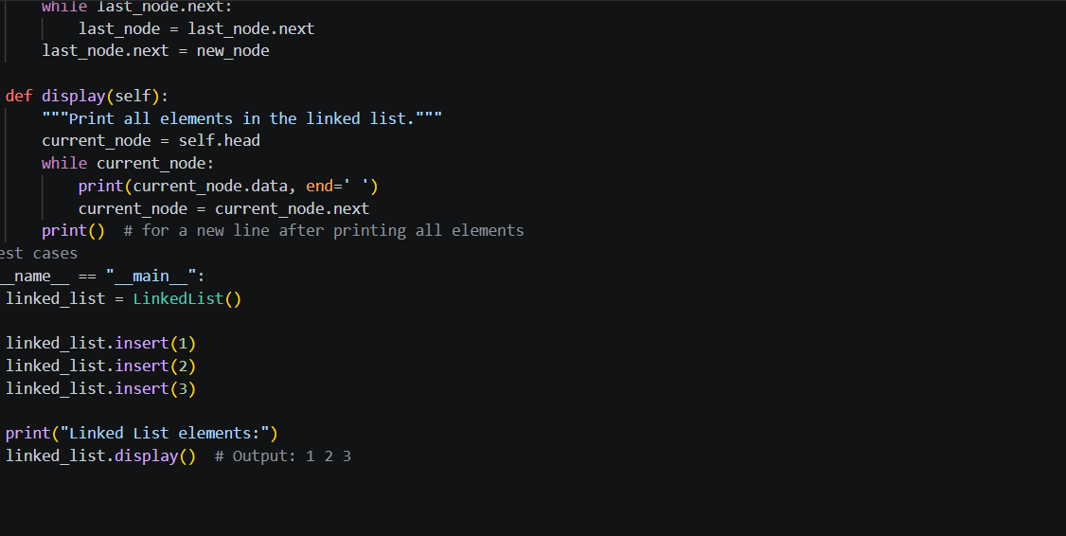
OUTPUT:
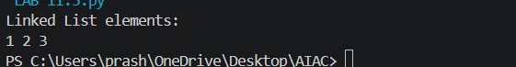
Task Description #4 – Hash Table
Task: Use AI to implement a hash table with basic insert, search, and
delete methods.
Sample Input Code:
class HashTable:
pass
Expected Output:
• Collision handling using chaining, with well-commented methods.
PROMPT:
#Implement a Hash Table in Python
#Methods:
#insert(key, value)
#search(key)
#delete(key)
#Use chaining (list in each bucket) for collision handling
#Add proper comments and docstrings
#Handle duplicate keys (update value)

CODE:
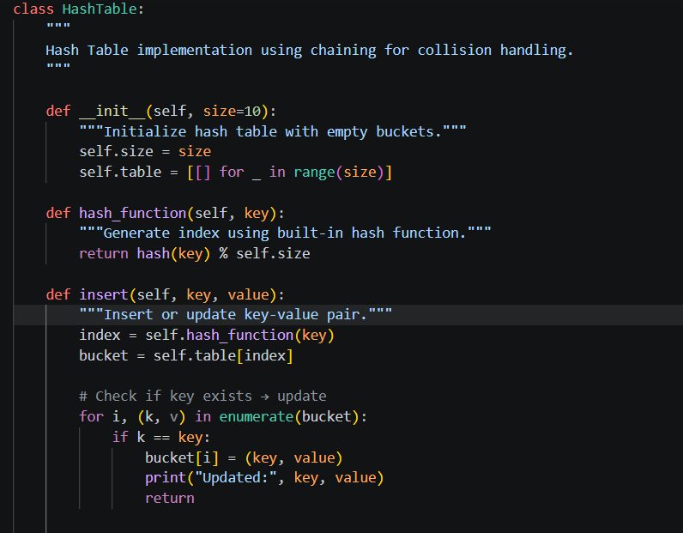
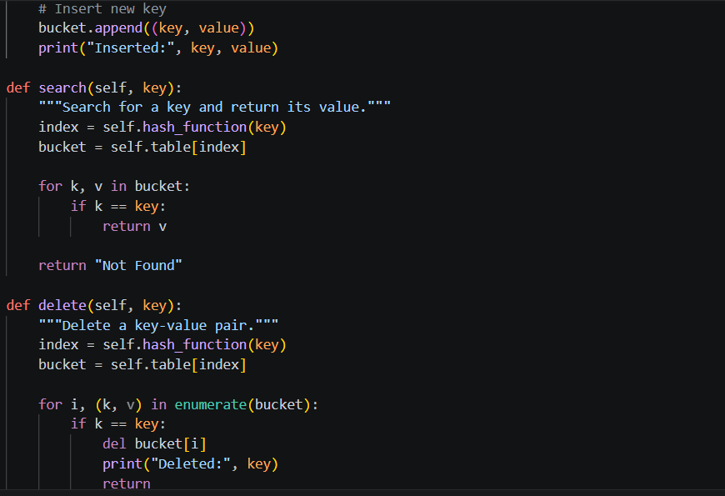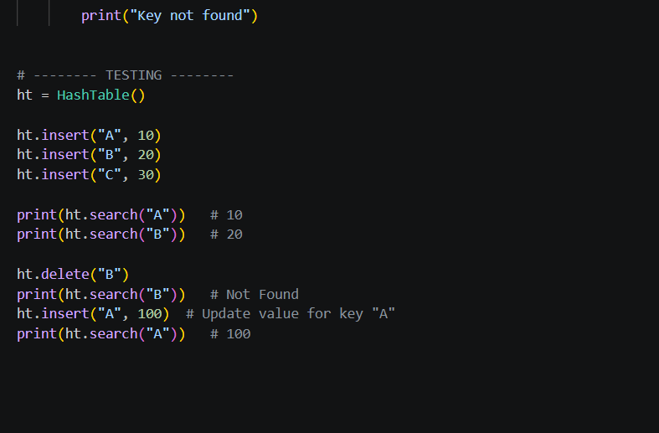
OUTPUT:
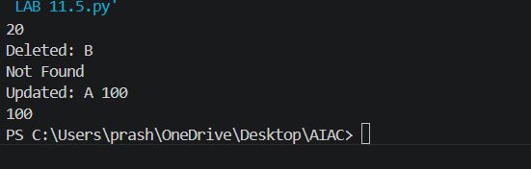
Task Description #5 – Graph Representation
Task: Use AI to implement a graph using an adjacency list.
Sample Input Code:
class Graph:
pass
Expected Output:
• Graph with methods to add vertices, add edges, and display
connections.
Prompt:
# Genearate a python code to Implement a Graph using adjacency list
#Create Graph class
# Methods:
#add_vertex(vertex)
#add_edge(v1, v2)
#display()
#Use adjacency list representation (dictionary)
#Add docstrings and comments
#Include test cases with output

CODE:
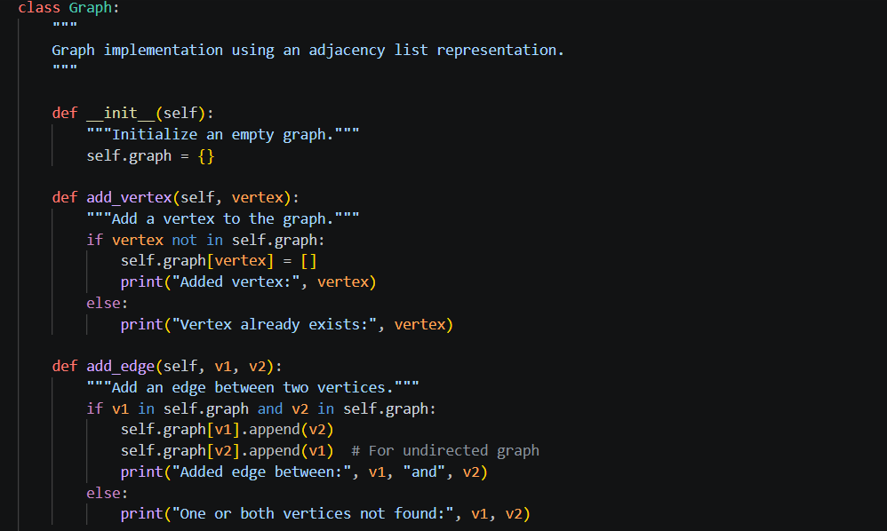
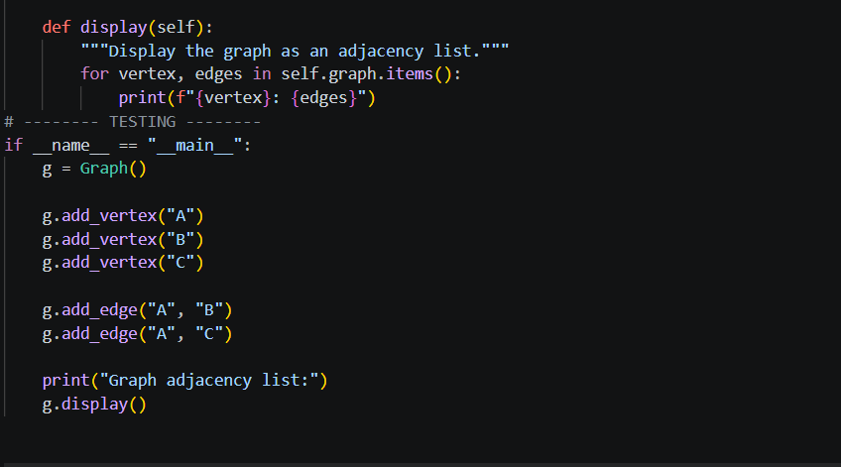
OUTPUT:
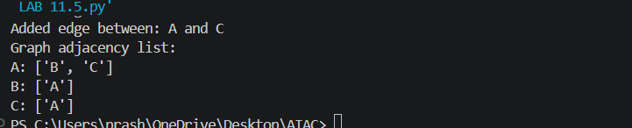
Task Description #6: Smart Hospital Management System – Data
Structure Selection
A hospital wants to develop a Smart Hospital Management System that
handles:
1. Patient Check-In System – Patients are registered and treated in
order of arrival.
2. Emergency Case Handling – Critical patients must be treated first.
3. Medical Records Storage – Fast retrieval of patient details using
ID.
4. Doctor Appointment Scheduling – Appointments sorted by time.
5. Hospital Room Navigation – Represent connections between
wards and rooms.
Student Task
• For each feature, select the most appropriate data structure from
the list below:
o Stack
o Queue
o Priority Queue
o Linked List
o Binary Search Tree (BST)
o Graph
o Hash Table
o Deque
• Justify your choice in 2–3 sentences per feature.
• Implement one selected feature as a working Python program with
AI-assisted code generation.
Expected Output:
• A table mapping feature → chosen data structure → justification.
• A functional Python program implementing the chosen feature
with comments and docstrings.
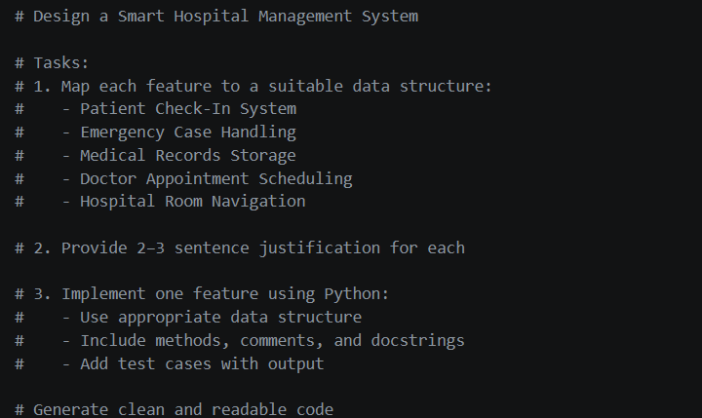
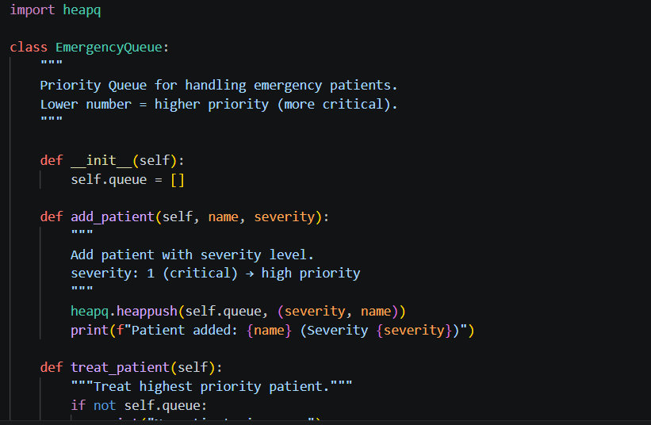
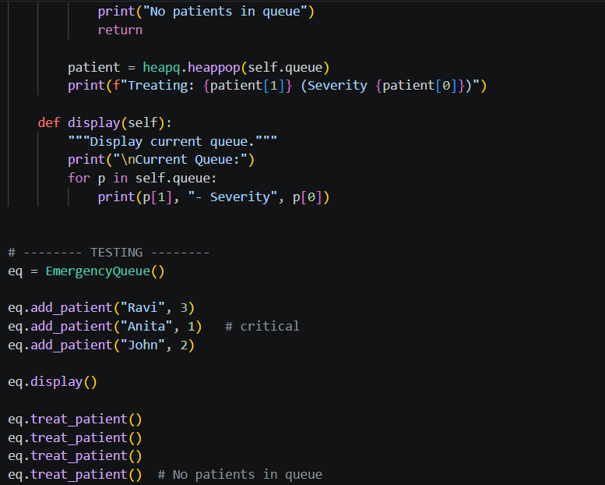
OUTPUT:
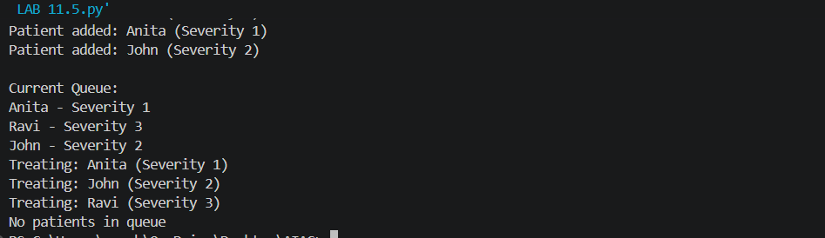
Task Description #7: Smart City Traffic Control System
A city plans a Smart Traffic Management System that includes:
1. Traffic Signal Queue – Vehicles waiting at signals.
2. Emergency Vehicle Priority Handling – Ambulances and fire trucks
prioritized.
3. Vehicle Registration Lookup – Instant access to vehicle details.
4. Road Network Mapping – Roads and intersections connected
logically.
5. Parking Slot Availability – Track available and occupied slots.
Student Task
• For each feature, select the most appropriate data structure from
the list below:
o Stack
o Queue
o Priority Queue
o Linked List
o Binary Search Tree (BST)
o Graph
o Hash Table
o Deque
• Justify your choice in 2–3 sentences per feature.
• Implement one selected feature as a working Python program with
AI-assisted code generation.
Expected Output:
• A table mapping feature → chosen data structure → justification.
• A functional Python program implementing the chosen feature
with comments and docstrings
PROMPT:
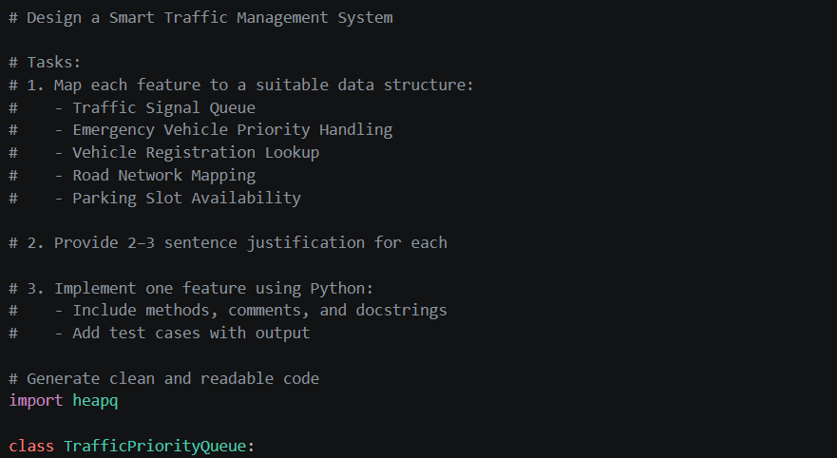
CODE:
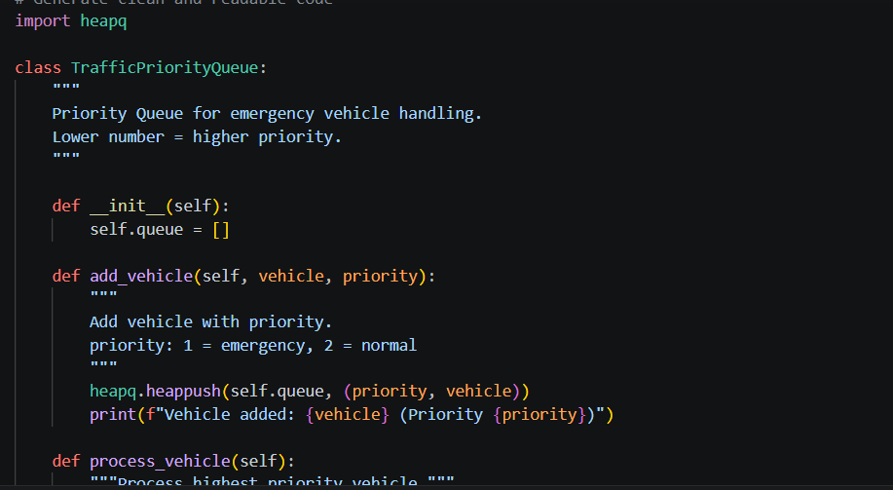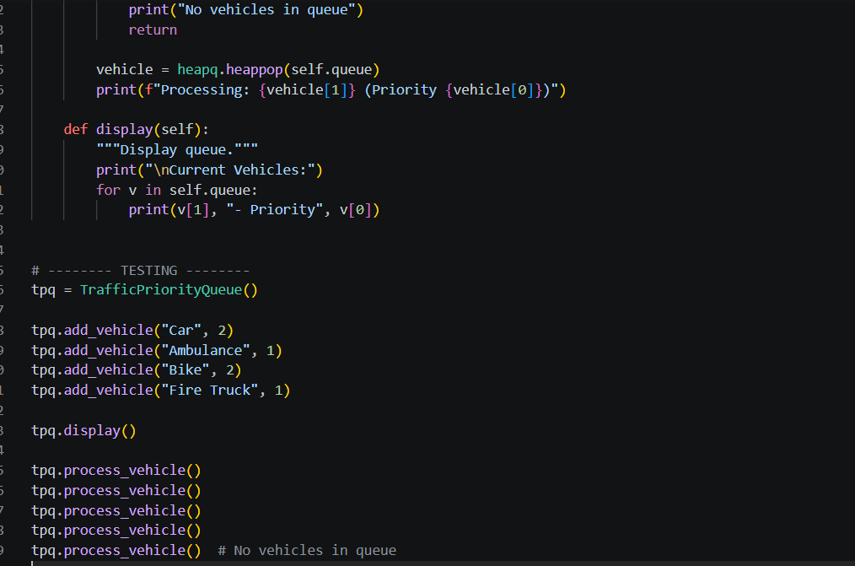
OUTPUT:
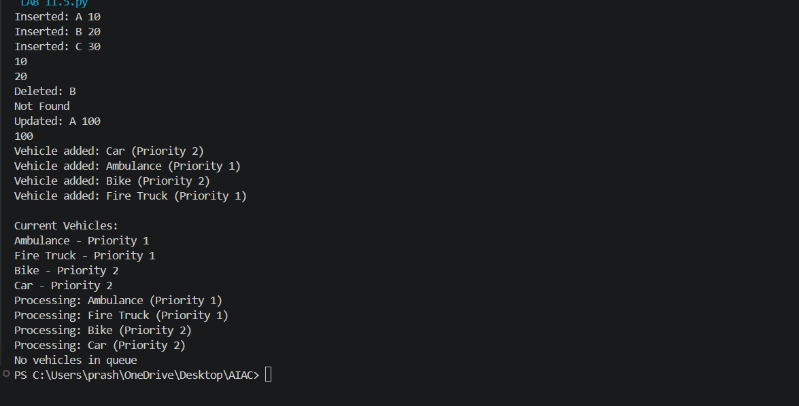

ask Description #8: Smart E-Commerce Platform – Data Structure
Challenge
An e-commerce company wants to build a Smart Online Shopping System
with:
1. Shopping Cart Management – Add and remove products
dynamically.
2. Order Processing System – Orders processed in the order they are
placed.
3. Top-Selling Products Tracker – Products ranked by sales count.
4. Product Search Engine – Fast lookup of products using product ID.
5. Delivery Route Planning – Connect warehouses and delivery
locations.
Student Task
• For each feature, select the most appropriate data structure from
the list below:
o Stack
o Queue
o Priority Queue
o Linked List
o Binary Search Tree (BST)
o Graph
o Hash Table
o Deque
• Justify your choice in 2–3 sentences per feature.
• Implement one selected feature as a working Python program with
AI-assisted code generation.
Expected Output:
• A table mapping feature → chosen data structure → justification.
• A functional Python program implementing the chosen feature
with comments and docstrings.
PROMPT:
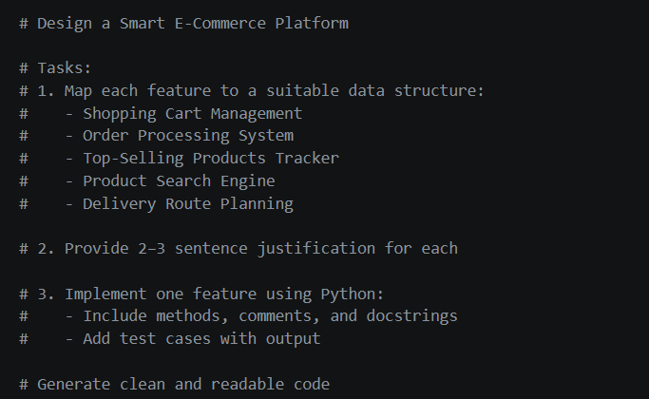
CODE:
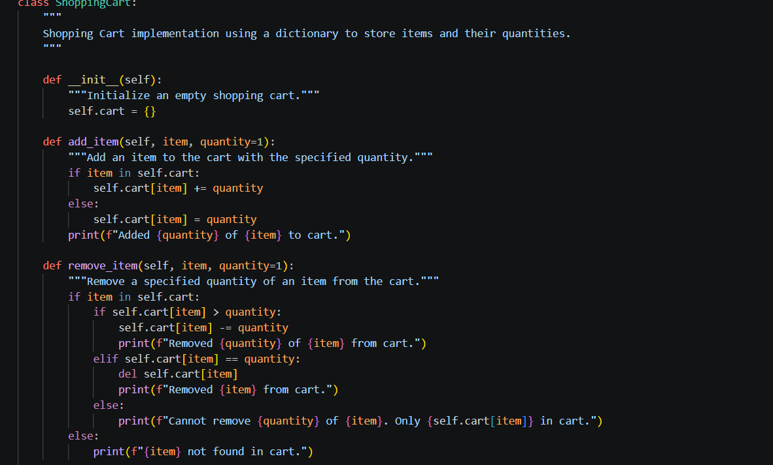
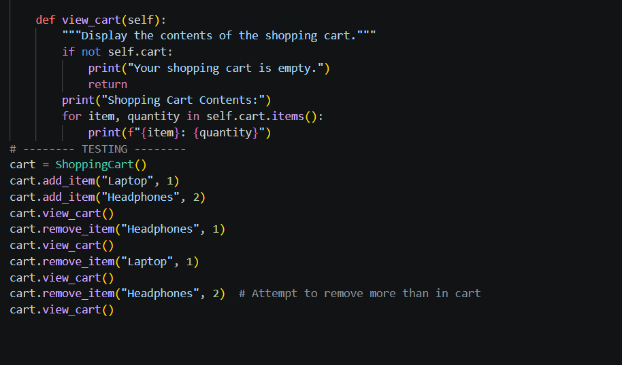
OUTPUT:
